Inventory Maintenance – QA (Make sure the screen centering function is added to the screen – Sathis can help)

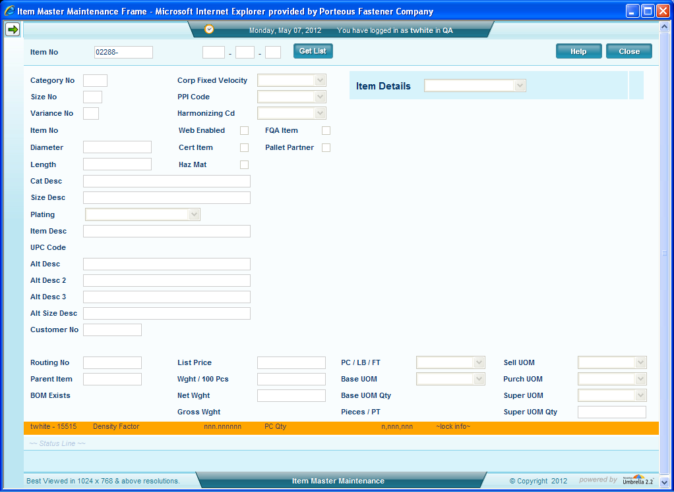
Screen 01 – Entering a new item
I expected to get an error when I entered an invalid 5 digit category no message in both locations the enter box and the Z item entry box

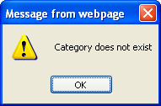
Screen 02 - Did get the message when I finished entering the item – I believe it to be better on the first entry

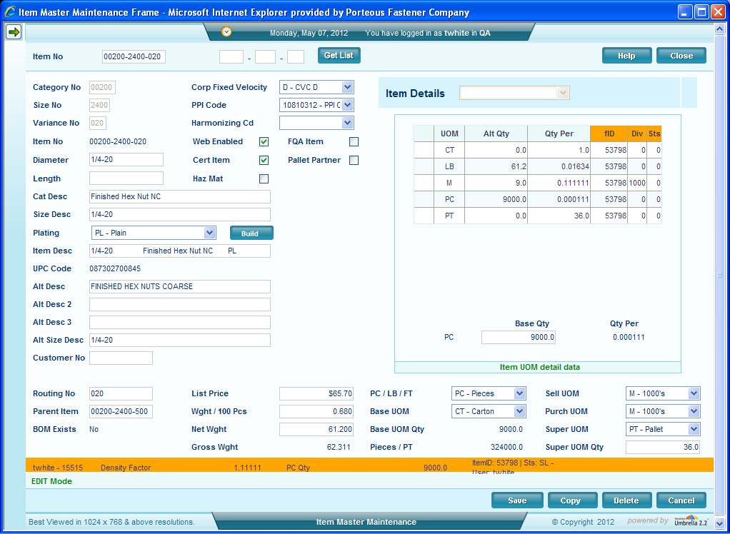
Screen 03 – Entering an existing item

When I entered a valid item the entire screen cleared itself and then came back with the data above – must we clear the entire web page?

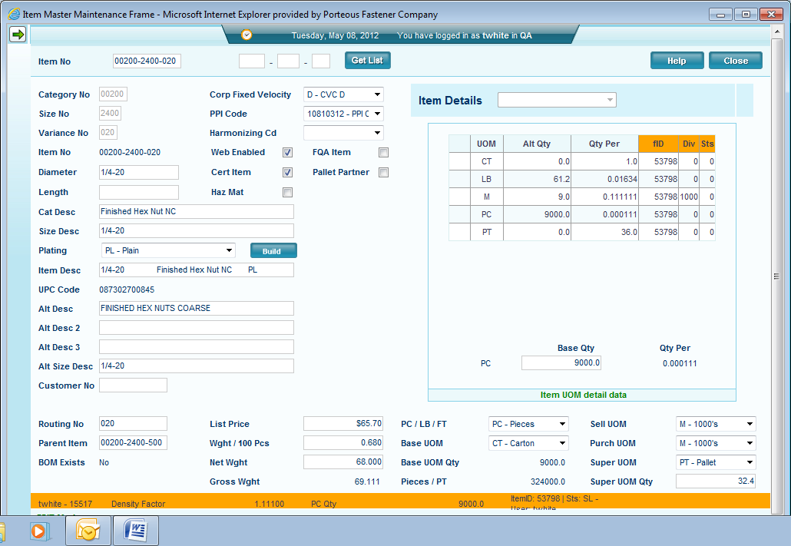
Screen 04 – entering changes to an existing item
When I enter a change to the base qty the screen shows the change and when I hit the save button I get the saved message – but when I return the data the change is not reflected – I had changed the 9000 pieces to 10,000 and returned the above display. If I change something in the body of the screen the data does save.

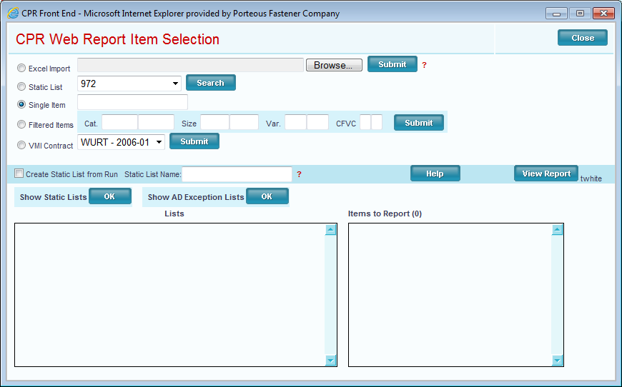
Screen 05: While on a 200-2400-020 item I open the side menu and selected CPR the item number was not past to CPR – Also on the CPR screen above the close button does not work.

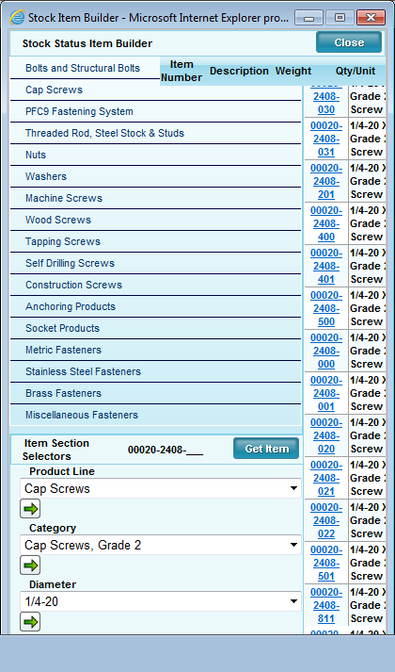
Screen 06 – Item builder screen does not fully open – can use it as is.

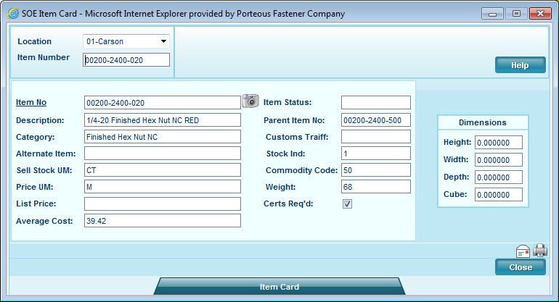
Screen 07 – Item card seems to be working correctly.

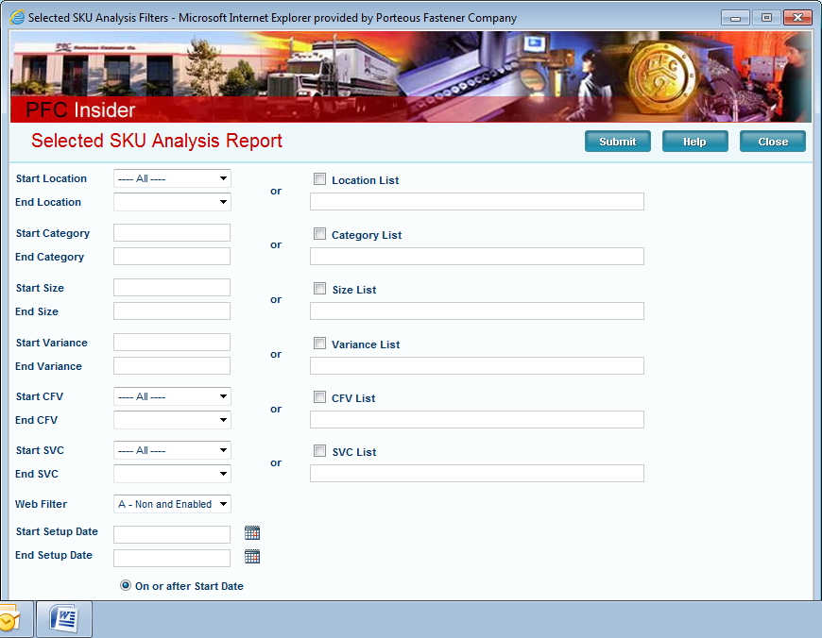
Screen 08 – Selected SKU analysis opens ok – Close button does not work

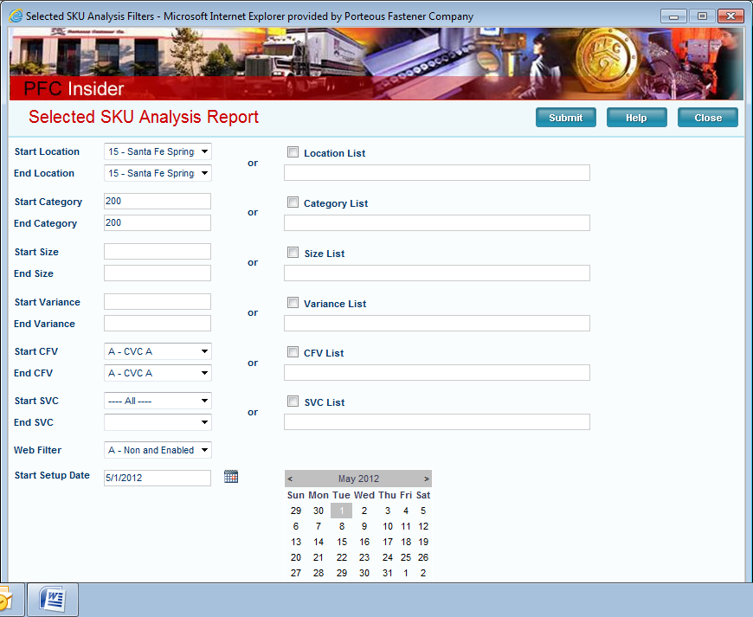
Screen 09 When using the Selected SKU Analysis you can’t get down to the ending date if you open the beginning date – see screen above

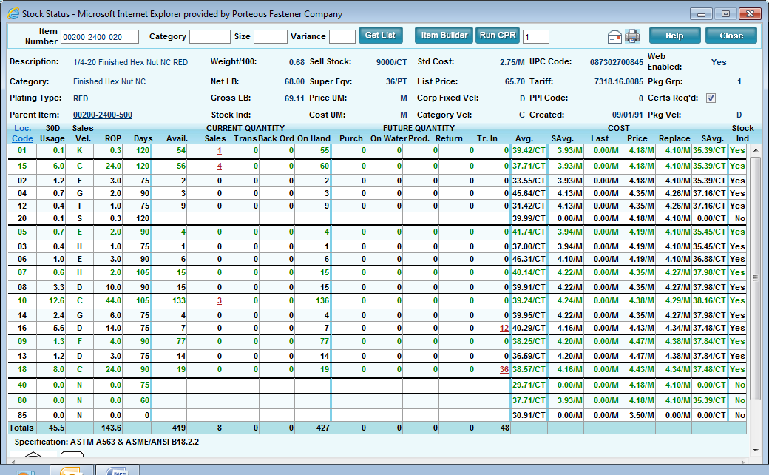
Screen 10 – Stock Status seems to run correctly – passes the Item number correctly - close button works

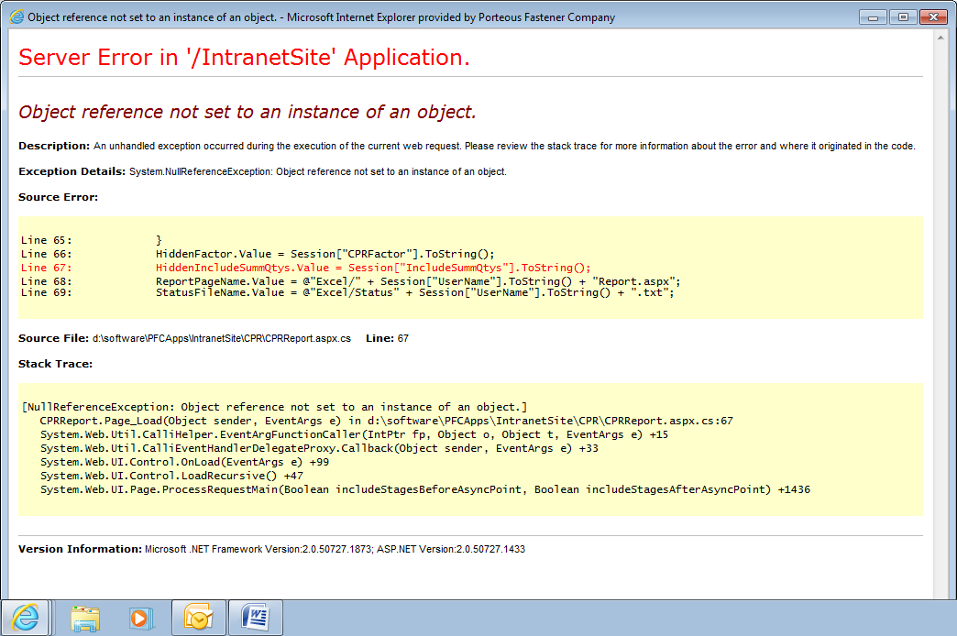
Screen 11 – the error shown above it when you run CPR from the screen above (Stock Status)

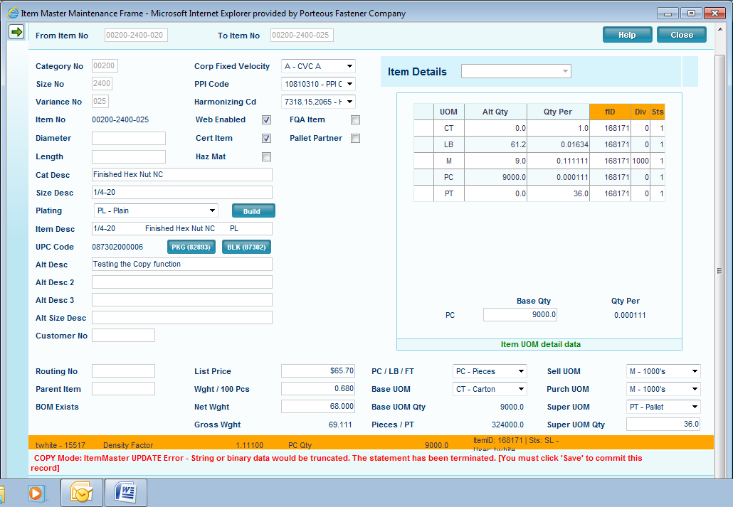
Screen 12 - Testing the copy function got this message – cannot save the item – it might need a diameter – I did a diameter on another one and it saved – The user should get a message as to what is missing before we can save it
When you use the copy function the Alt Description is not copied is that how Bruce wanted it?
CFV (need to default to ‘I’), PPI, Ham Code, are not copied and this is a good thing they can be blank I assume -
However, I believe the UPC has to be selected or we should not save the screen – currently it will save without the UPC being selected. (Check with Bruce)

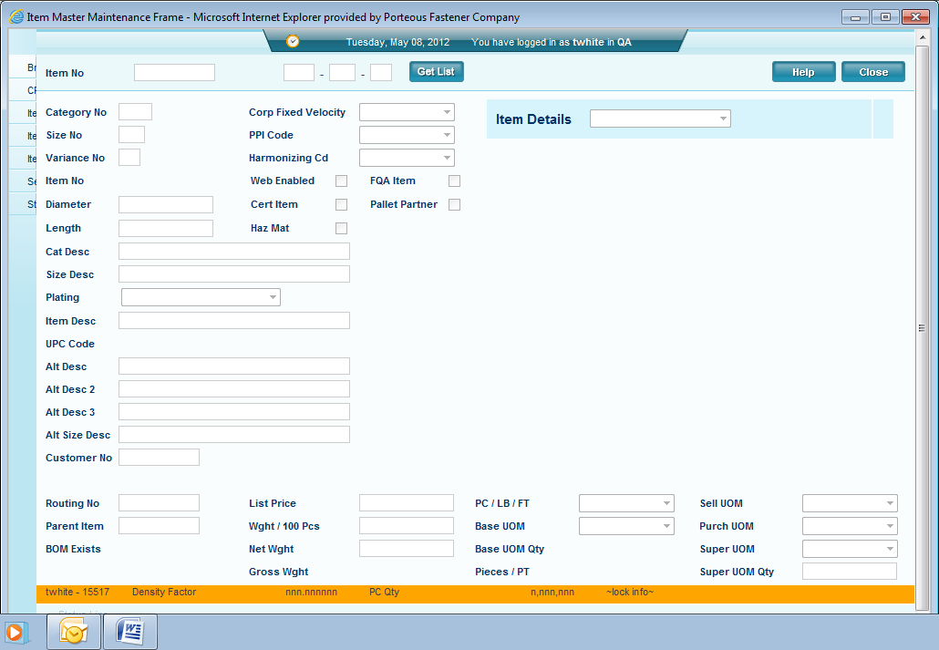
Screen 13 – When you first come into the screen you cannot open the left side menu – when you put your item number in and hit enter then you can see the side menu arrow.

Screen 14

